Crash Course in Vector Mathematics

As a geometrical object, a vector is a line that has a length and a direction (denoted by an arrow). It can be used to represent measurements such as displacement, velocity, and acceleration. You can think of a vector as a change in location of coordinates, with the values of the vector representing the amounts of coordinate change. An example of a vector is given in Figure 1.

In Figure 1, the vector, **v**, is the displacement from **P to Q.** It can be thought of as a set of coordinate instructions where the first value is a change in the *x-*direction and the second is a change in the y-direction. For example, if we are lo­cated at point **P** and we traverse **v**, we end up at **Q.** The value of v can be calculated by subtracting the coordinates of the start location from the coordinates of the end location. This formula is shown in Equation 1.

**EQUATION 1.**

**v = Q - P**

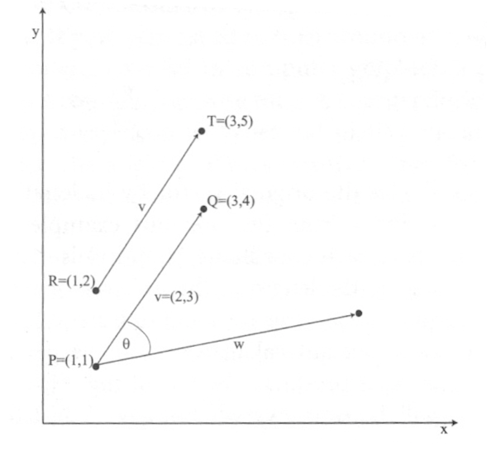

**FIGURE 1** The graphical representation of a vector.

In the example shown in Figure 1, **v** can be calculated as (*Qx - Px*, *Q*y - *P*y) = (3 - 1, 4 - 1) = (2,3).

If the vector from **Q to P** were required, the calculation would be reversed, thus, (*Px - Qx*, Py - Qy)*= (1 -* 3, 1 - 4) = (-2,-3). The resulting value makes sense because the magnitude of the vector from **P to Q** is the same as that from **Q to P;** however, the direction of travel is opposite and, therefore, you have negative values.

A vector does not specify a fixed starting location. It can start and end any­where, depending on its application. If, for example, there was a point **R = (1,2),** vector, **v**, could be added to this point as directions to a new point, **T**. To determine the location of **T**, simply add **R** and **v**, as shown in Equation 2.

**EQUATION 2.**

**T = R + v**

In this case, the location of **T** would be (Rx + vx, *Ry + Vy) = (1 +* 2, 2 + 3) = (3, 5). Often it is useful to know the length of a vector. The length of vector, **v,** in the previous example would tell us the distance between points **P** and **Q** or **R** and **T**. The length of a vector, denoted ||**v**|| is found using Pythagoras' Theorem, shown in Equation 3.

**EQUATION 3.**

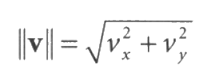

Here, the length of **v** is

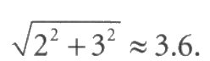

Sometimes it is necessary to scale a vector so that it has a unit length. There­fore, the length of the vector is equal to 1. The process of scaling the length is called normalizing, and the resultant vector, which still points in the same direction, is called a unit vector. To find the normalized form of a vector, Equation 4 is used.

**EQUATION 4.**

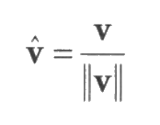

The equation divides the original vector by its length to calculate the unit vector. The unit vector for **v** from the previous example would be:



where each coordinate *(x* and y) is divided by the vector's length. If you were to calculate the length of the unit vector using Equation 3, you would find it would equal 1 (excusing any rounding errors).

Two further important calculations can be performed with vectors: the dot product and the cross product. The use of these in computer graphics and games programming will become overwhelmingly clear later in this appendix. Among other things, the dot product can be used to calculate the angle between two vec­tors, and the cross product can be used to calculate direction.

The dot product is calculated by taking two vectors, **v** and **w,** and multiplying their respective coordinates together, then adding them. The dot product results in a single value. It can be calculated using Equation 5.

**EQUATION 5.**

*v · w* = *v*x*w*x + *v*y*w*y

Given the vectors **v** = (2,3) and **w** = (5,1), the dot product will be 2 · 5 + 3 · 1 = 13. But what does this mean? The most useful application of the dot product is working out the angle between two vectors. In a moment we will work out the actual value of the angle, but for now, by just knowing the value of the dot product you can determine how the vectors sit with relation to each other. If the dot product is greater than 0, the vectors are less than 90° apart, if the dot product equals 0, then they are at right angles (perpendicular), and if the dot product is less than 0, then they are more than 90° apart.

To determine the exact angle between two vectors, for example, *θ* Figure 1, the *arccosine* of the dot product of the unit vectors is found (see Equation 6). This value is the angle between the vectors. See [Hill01] for a derivation if desired.

**EQUATION 6.**

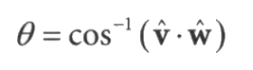

Now imagine that you are standing at point **P** (in Figure 1) and facing in the di­rection of **v.** How far should you turn (on the spot) to be facing in the direction of **w**? It's as easy as using Equation 6 ... or is it? Let's find out. Given the previous values for **v** and **w,** the value of *θ* will be cos-1((0.556, 0.833) · (0.980,0.196)) = cos-10.708 = 44.9°. So the angle between **v** and **w** is about 45°. Therefore, if you were to turn around 45°, you would be facing in the direction of **w.** This, however, is not necessarily true. If you were asked to turn around 45°, which way would you go? Clockwise or counterclockwise? In computer graphics, a positive value for an angle always indicates a counterclockwise turn. A counterclockwise turn in this case would have you facing away from **w**. When calculating the angle between vectors using the dot product, the angle is always positive. Therefore, you need another method to determine the turn direction. This is where the cross product comes into play.

The cross product of two vectors results in another vector. The resulting vector is perpendicular to both the initial vectors. This would sound odd working in two dimensions because obviously a vector at right angles to two vectors in two dimen­sions would have to come right out of the page. For this reason, the cross product is defined only for three dimensions. The formula to work out the cross product is a little obtuse and requires further knowledge of vector mathematics, but we will try to make it as painless as possible here.

The cross product of two vectors, **v** and **w**, denoted **v** x **w**, is shown in Equation 7.

**EQUATION 7.**

**v** x **w** = (vyw*z* - *vz wy* )(1, 0, 0) + (vzwx - *vxwz* )(0,1,0) + (v*x*wy - *vy*wx)(0,0,1)

The equation is defined in terms of the standard unit vectors. See [Hill01] for deri­vation if desired. These vectors are three unit-length vectors orientated in the direc­tions of the x-, y- and z-axes (see Figure 2). If you examine Equation 7 you will notice there are three parts added together. The first part determines the value of the x-coordinate of the vector because the unit vector (1,0,0) has a value only for the x-coordinate. The same occurs in the other two parts for the y- and *z-*coordinates.

To find the cross product of two 2D vectors, the vectors first must be converted into three-dimensional coordinates. This process is as easy as adding another coor­dinate value of 0 to denote that the vectors do not have a value in the z-direction. For example, **v** = (2,3) becomes **v** = (2,3,0) and **w** = (5,1) becomes **w** = (5,1,0). The value of **v** x **w** would equate to

(3*·*0-0*·*1)(1,0,0)+(0*·*5-2*·*0)(0,1,0)+(2*·*1-3*·*5)(0,0,1)  
= 0(1,0,0)+ 0(0,1,0)+(-13)(0,0,1)  
= (0,0,0)+ (0,0,0)+ (0,0,-13)  
= (0,0,-13).

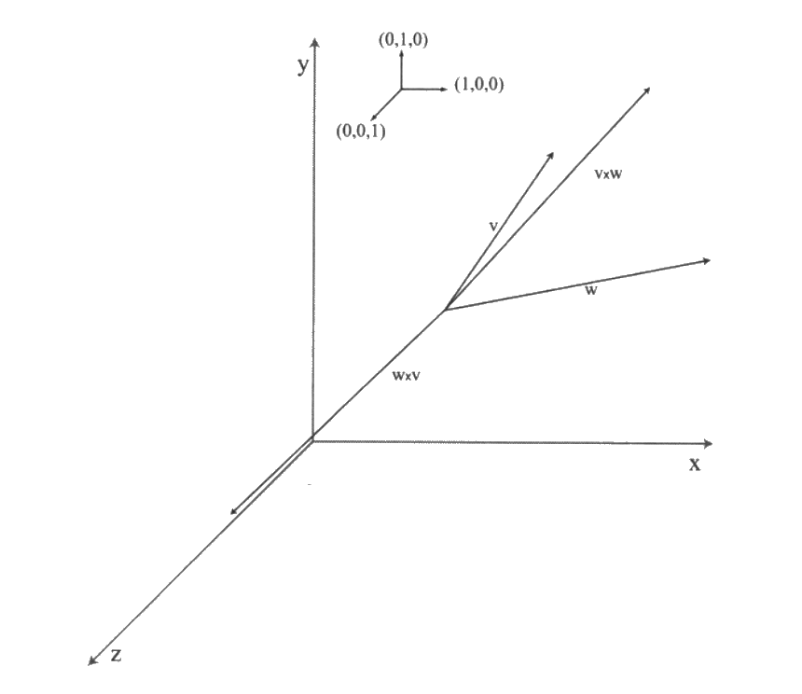

**FIGURE C.2** Unit vectors and resulting cross product vectors.

It doesn't appear to be the resulting vector because it is shown in Figure 2 at right angles to both **v** and **w** and is seven units long in the z-direction. An interest­ing thing to note about the cross product is that if the order of the equation is re­versed, the resulting vector is different. **w** x **v** would equal (0,0,13) (check this out!), which is a vector the same length as the one produced by **v** x **w**, but it travels in the exact opposite direction (see Figure 2). This differs from the calculation of the dot product, which yields the same answer no matter what the order of the vec­tors. So how does this help us determine the direction in which to turn?

If we start facing in the direction of **v** and want to turn to face **w**, we can calcu­late **v** x **w**. If we examine Figure 2, it is plain to see that w would be on our right, and, therefore, it would require a clockwise turn. This fact is not obvious to a vir­tual human who has only the vector coordinates. We know from the previous ex­ample that a clockwise turn between two vectors produces a cross product result with a negative z-value. The opposite is true for an counterclockwise turn. There­fore, we can say that if *z* is positive, it means a counterclockwise turn, and if *z* is negative, a clockwise turn.

This concludes our crash course on vector mathematics.

**REFERENCES**

[Hill01 ] Hill, J.S., *Computer Graphics Using OpenGL,* Prentice Hall, Upper Saddle River, 2001.